**[Activity diagram for Ecommerce website](https://meeraacademy.com/activity-diagram-for-online-shopping-website/)**

Activity diagram for online shopping system

The activity diagram used to describe flow of activity through a series of actions. Activity diagram is a important diagram to describe the system.  
The activity described as a action or operation of the system.

Activity Diagram for User Side

In User side activity diagram describe all the functionality or operation of users can do on our website.

[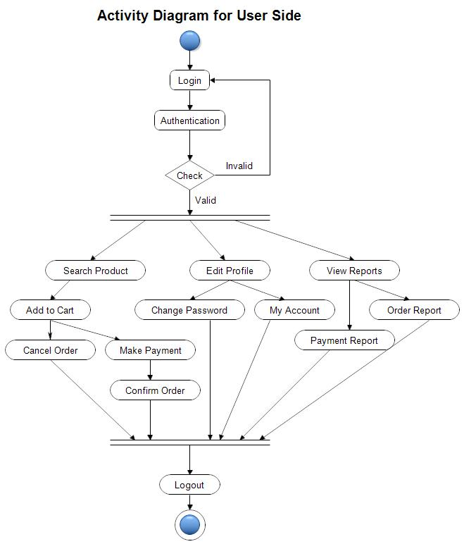](https://www.youtube.com/coderbaba)Activity diagram for Ecommerce website – user side

Activity diagram for Admin side

[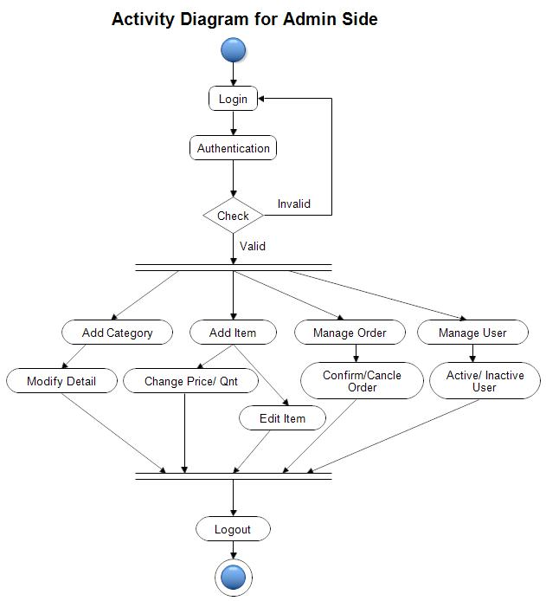](https://www.youtube.com/coderbaba)Activity diagram for Ecommerce website – Admin side